

Eircode Web Form & Dynamics 365 Integration Design

Prepared by | Gerry Whelan
Date first issued | 17/07/2026
Last updated
Version
Document  Classification | Confidential

Document Control

Version History

Version | Date Released | Contributor(s) | Description
0.8 | 17/07/2026 | Gerry Whelan | Initial draft

Document Approval

Approved by | Position | Date

Distribution List

Distributed to | Company | Position | Date

Contents
1. Introduction 2
1.1 Purpose 2
2. Web Form Design 2
2.1 Introduction 2
2.1.1 Description 2
2.1.2 General Contact Form 2
2.2 Technical/API Open Data Feedback Form 4
3. Web Form Schema Design 6
3.1 Introduction 6
3.2 Schema Design 6
3.2.1 Description 6
3.2.2 Schema Definition 6
3.2.3 Schema Versioning 9
4. Web Form to D365 Integration 10
4.1 Introduction 10
4.2 Calling the Dataverse Web API 11
4.3 Expected Dataverse Web API Return codes 11
4.4 Dataverse Web API Authentication & Authorisation 11
4.4.1 Approach 11
4.4.2 Entra ID Setup Requirements 12
4.4.3 Dataverse Setup Requirements 12
4.4.4 High-level Auth. Flow 12
4.4.5 Channel Encryption 12
4.5 High-level End-to-End Integration Architecture 12
4.5.1 Description 12
4.5.2 Solution Processing Flow 13

References

# | Description | Source
1 | Eircode Web BRD 2.5 | Eircode BRD v2.5
2 | Web site web form | Web Form design
3 | Using the Microsoft Dataverse Web API | Using the Microsoft Dataverse Web API
4 | Dataverse Web API Auth. | Dataverse Web API Auth
5 | Eircode Quality Masterfile with Webform Mapping | Eircode Quality Masterfile with Webform Mapping
Table 1 References

Introduction

Purpose
This document describes the proposed design to integrate Eircode web form data with the D365 contact solution.
It addresses the schema design which acts as a standardised data format for the web form data exchange along with the client considerations supporting the proposed approach to interfacing with a published Dataverse Web API.

Web Form Design

Introduction
There is a requirement for two web forms which are comprised of standard HTML text boxes, static drop-down lists and submit/cancel buttons. Contact Form Data Design

Description
Two contact web forms require to be integrated to with the D365 content solution. These are detailed in the Eircode BRD 2.5 (reference 1) and the Web form design (reference 2). They are replicated here for reference purposes.

General Contact Form
The General Contact Form is accessed through the Support/Contact journey at eircode.ie/contact. It is intended for members of the general public and business users who have non-technical queries. Submissions from this form are routed to the Customer Contact (CC) Team queue in Dynamics 365.
The functional definition of this form is specified in the Web site web form specification, reference 2 and in the Eircode Quality Masterfile with Webform Mapping Excel, reference 5.

Technical/API Open Data Feedback Form
The Technical/API Open Data Feedback Form is accessed through the Open Data section at eircode.ie/open_data. It is intended for technical users, developers, and public sector bodies with queries or feedback on datasets, APIs, or Open Data usage. Submissions from this form are routed to the Technical/Open Data queue in Dynamics 365, and the Feedback Type dropdown determines which conditional fields are presented.
The functional definition of this form is specified in the Web site web form specification, reference 2 and in the Eircode Quality Masterfile with Webform Mapping Excel, reference 5.

Web Form Schema Design

Introduction
This section defines the schema used to structure web form submissions before they are transferred. The schema specifies the data elements captured from both the General Contact Form and the Technical/API Open Data Feedback Form.

Schema Design

Description
It is proposed to use JSON to capture the form data along with its supporting schema Open JSON-schema.org.
The schema enforces validated rules and basic logic governing the syntax of the submitted form data. This excludes semantics, e.g. checking for a correct email address vs. a correctly formed email.

Schema Definition

Contact Form Schema
The following defines the proposed content form JSON schema definition for the contact submission form.
{
"$schema": "https://json-schema.org/draft/2020-12/schema",
"title": "Customer Contact Form Submission",
"id": "https//schema.eircode.ie/web-forms/contact/v1.0.0/schema.json",
"type": "object",
"properties": {
"firstName": {
"type": "string",
"minLength": 1,
"maxLength": 150
},
"lastName": {
"type": "string",
"minLength": 1,
"maxLength": 150
},
"emailAddress": {
"type": "string",
"format": "email",
"maxLength": 200
},
"phoneNumber": {
"type": "string",
"maxLength": 200
},
"organisation": {
"type": ["string", "null"],
"maxLength": 200
},
"referenceNumber": {
"type": ["string", "null"],
"maxLength": 200
},
"issueType": {
"type": "string",
"enum": [
"eircodeInfoAndGuidance",
"dataQualityAndChangeRequests",
"openDataPlatformTechnical",
"dataInterpretation",
"postPublicationInterest",
"newEircodeActivation",
"suppressionReclassification",
"governanceAndRights",
"commercialAndDataReuse",
"platformIncident",
"disputesComplaints",
"systemicDataFeedback"
]
},
"issueSubcategory": {
"type": "string",
"enum": [
"gettingAnEircode",
"usingAnEircode",
"addresses",
"eircodeFinder",
"eircodeForBusinesses",
"eircodeDesign",
"miscellaneousGuidance",
"eircodeOrFinderRelated",
"underlyingPostalAddress",
"coordinatesMapOrRedDot",
"irishLanguage",
"organisationOrHouseNameChange",
"technicalIntegrationQueries",
"technicalIssues",
"platformData",
"datasetStructureOrSchema",
"statisticalOrAggregateInterpretation",
"comparisonsAndExternalAlignment",
"generalPublicationQueries",
"pressOrMedia",
"newBuildOrCommencements",
"generalEircodeOrActivationRequest",
"suppressionRequest",
"reclassificationRequest",
"freedomOfInformation",
"parliamentaryOrMinisterialQuery",
"localAuthorityOrPublicSector",
"mediaOrJournalistQuery",
"commercialLicensingAndBusinessUse",
"dataReuseTermsConditionsAndAttribution",
"commercialSupportAdvisoryOrConsultancy",
"platformAvailabilityOrOutage",
"performanceOrLatency",
"errorsOrUnexpectedBehaviour",
"downloadOrAccessFailure",
"browserDeviceOrEnvironmentIssue",
"serviceComplaint",
"escalationOrCaseReview",
"bulkOrSystemicDataFeedback"
]
},
"eircode": {
"type": ["string", "null"],
"pattern": "^[A-Z][0-9][A-Z0-9]{5}$",
"description":"Optionally captured for issueType:LookupIssue,IncorrectAddressDataIssue,DataQuery,DataSuppressionReclassification"
},
"customerServiceCaseReference": {
"type": ["string", "null"],
"pattern": "^CAS-[0-9]{8}$",
"description": "Customer Service case reference in the format CAS-########, where the numeric portion is exactly eight digits and left-padded with zeros where necessary.",
"examples": [
"CAS-00000001",
"CAS-00001234"
]
},
"addressLine1": {
"type": ["string", "null"],
"maxLength": 200,
"description":"Optionally captured for issueType:LookupIssue,IncorrectAddressDataIssue,DataQuery,DataSuppressionReclassification"
},
"addressLine2": {
"type": ["string", "null"],
"maxLength": 200,
"description":"Optionally captured for issueType:LookupIssue,IncorrectAddressDataIssue,DataQuery,DataSuppressionReclassification"
},
"addressLine3": {
"type": ["string", "null"],
"maxLength": 200,
"description":"Optionally captured for issueType:LookupIssue,IncorrectAddressDataIssue,DataQuery,DataSuppressionReclassification"
},
"addressLine4": {
"type": ["string", "null"],
"maxLength": 200,
"description":"Optionally captured for issueType:LookupIssue,IncorrectAddressDataIssue,DataQuery,DataSuppressionReclassification"
},
"addressLine5": {
"type": ["string", "null"],
"maxLength": 200,
"description":"Optionally captured for issueType:LookupIssue,IncorrectAddressDataIssue,DataQuery,DataSuppressionReclassification"
},
"addressTown": {
"type": ["string", "null"],
"maxLength": 100,
"description":"Optionally captured for issueType:LookupIssue,IncorrectAddressDataIssue,DataQuery,DataSuppressionReclassification"
},
"addressCounty": {
"type": ["string", "null"],
"maxLength": 100,
"description":"Optionally captured for issueType:LookupIssue,IncorrectAddressDataIssue,DataQuery,DataSuppressionReclassification"
},
"addressID": {
"type": ["string", "null"],
"maxLength": 100,
"description":"Unique Autoaddress ID optionally captured for issueType:LookupIssue,IncorrectAddressDataIssue,DataQuery,DataSuppressionReclassification"
},
"addressReference": {
"type": ["string", "null"],
"maxLength": 100,
"description":"Geodirectory address reference optionally captured for issueType:LookupIssue,IncorrectAddressDataIssue,DataQuery,DataSuppressionReclassification"
},
"descriptionOfIssue": {
"type": "string",
"minLength": 1,
"maxLength": 1000
},
"additionalNotes": {
"type": ["string", "null"],
"maxLength": 400,
"description":"Optionally captured for issueType: GeneralQuestion,ComplaintDispute,GovernanceFOIPublicQuery,CommercialDataUseQuery"
},
"platformContext": {
"type": ["string", "null"],
"maxLength": 3000
}
},
"required": [
"firstName",
"lastName",
"emailAddress",
"issueType",
"descriptionOfIssue"
],
"additionalProperties": false
}

Figure 1 Contact form schema

Technical Form Schema
{
"$schema": "https://json-schema.org/draft/2020-12/schema",
"title": "Technical Contact Form",
"description": "Defines the data submitted through the Technical Contact Form.",
"type": "object",

"properties": {
"schemaVersion": {
"type": "string",
"const": "1.0",
"description": "Version of the technical contact form data contract."
},

"firstName": {
"type": "string",
"minLength": 1,
"description": "Contact first name."
},

"lastName": {
"type": "string",
"minLength": 1,
"description": "Contact last name."
},

"emailAddress": {
"type": "string",
"format": "email",
"description": "Contact email address."
},

"organisation": {
"type": [
"string",
"null"
],
"description": "Organisation or company name."
},

"phoneNumber": {
"type": [
"string",
"null"
],
"pattern": "^\\+?[0-9()\\- ]{7,20}$",
"description": "Contact telephone number. Required when the preferred contact method is phone."
},

"preferredContactMethod": {
"type": [
"string",
"null"
],
"enum": [
"email",
"phone",
null
],
"description": "The contact's preferred method of communication."
},

"feedbackType": {
"type": "string",
"enum": [
"apiIssue",
"datasetQuery",
"documentationFeedback",
"breakingChangeNotice",
"accessDownloadIssue"
],
"description": "The main reason for submitting the technical contact form."
},

"datasetApiReference": {
"type": [
"string",
"null"
],
"description": "Optional dataset, API or technical item reference. This field may be presented for API issues, dataset queries and access or download issues."
},

"description": {
"type": "string",
"minLength": 1,
"description": "Detailed description of the query, issue or feedback."
},

"additionalNotes": {
"type": [
"string",
"null"
],
"description": "Optional supplementary information."
}
},

"required": [
"schemaVersion",
"firstName",
"lastName",
"emailAddress",
"feedbackType",
"description"
],

"allOf": [
{
"if": {
"properties": {
"preferredContactMethod": {
"const": "phone"
}
},
"required": [
"preferredContactMethod"
]
},
"then": {
"required": [
"phoneNumber"
],
"properties": {
"phoneNumber": {
"type": "string",
"minLength": 1,
"pattern": "^\\+?[0-9()\\- ]{7,20}$"
}
}
}
}
],

"additionalProperties": false
}

Schema Versioning

Description
Versioning the schema enables future changes while preserving existing integrations and submitted data formats.
There are two aspects to the JSON schema that need versioning;
- The JSON schema standard itself. This will be updated in response to changes to the public standard.
- The schema supporting the web form data. This will be updated should the form data and/or D365 data capture need to change.
These are described in the following sub-sections.

JSON Schema Standard Versioning
The JSON Schema will have its published version updated:

"$schema": "https://json-schema.org/draft/2020-12/schema"
Changes will occur by updating the $schema value.

Web Form JSON Data
It is proposed to use the following id property with a version field to reflect web form data changes.
For the main contact form:
"id": "https//schema.eircode.ie/web-forms/contact/v1.0.0/schema.json"

For the technical feedback form:
"id": "https//schema.eircode.ie/web-forms/technical/v1.0.0/schema.json"

The version segment (v1.0.0) will follow the following change convention:
< mayor >.< minor >.< patch >
Changes to each element reflect the following types of changes. The following table outlines sample changes for each.

Same Change Type Changes | Version Change
Update/correct a property description | Patch
Increase minimum length | Minor
Increase field size | Minor
Remove a list type, e.g. issueType | Mayor
Table 4 Schema version segment changes

Web Form to D365 Integration

Introduction
This section describes the proposed integration approach between the Eircode web forms and the D365 contact centre solution.

Calling the Dataverse Web API
It is proposed to transfer the submitted custom web form data via a standard Dataverse Web API exposed by the D365 solution. This will create a row on an internally nominated table or tables with write permissions granted.
The following type of HTTPS POST operation will be used to transfer the client data. Specifics will be detailed in the Dynamics 365 low-level design (reference 3).

POST https://<environment>.crm.dynamics.com/api/data/v9.2/<staging-entity-set-name>
Authorization: Bearer <token>
Content-Type: application/json

Expected Dataverse Web API Return codes
The following table of HTTP returns codes are expected denoting success and failure.

HTTP Status | Description | Expected Action
201 Created | Staging record successfully created | Continue processing
400 Bad Request | Invalid request payload or schema validation failure | Log and return validation error
401 Unauthorized | Invalid or expired OAuth token | Refresh/reacquire token and retry if appropriate
403 Forbidden | Application user lacks Dataverse permissions | Raise operational error
429 Too Many Requests | Dataverse throttling | Retry using exponential backoff
500 Internal Server Error | Dataverse processing failure | Log and retry according to policy
503 Service Unavailable | Temporary service outage | Retry according to resilience policy
Table 5 Dataverse Web API Return Codes

Dataverse Web API Authentication & Authorisation

Approach
The integration will use OAuth 2 client-credential flow for server-to-server authentication to the Dataverse Web API (reference 4).

Entra ID Setup Requirements
To use Entra ID, the following setup needs to happen.
- Create an App Registration on Entra ID.
- Setup the client secrets.

Dataverse Setup Requirements
Dynamics 365 will need to associate the Entra application with a Dataverse application user and give that user an appropriate security role.

High-level Auth. Flow
An Post Entra ID service will act as the OAuth 2.0 token issuer. The web application will authenticate using its application identity and obtain an access token through the client-credential flow.
The web application will attach the access token to the Dataverse web API request using the ‘HTTP Authorization: Bearer’ header as mentioned previously.
Dataverse will validate the token and resolve the calling application identity to a Dataverse application user.
Microsoft Authentication Libraries (MSAL) can be used during the web application development to handle token acquisition and caching.

Channel Encryption

Transport Security
All communication between the web application and the Dataverse/Entra ID will be encrypted using HTTPS.
This will require the setup of a server certificate on the new D365 environment.

Client Security
Subject to GTS security policy and best practices, it is expected that a client certificate (X509) will be required by the web application to authenticate to Entra ID when requesting API tokens.

High-level End-to-End Integration Architecture

Description
This section provides a high-level end-to-end view of the web integration solution.
The custom web forms application will be hosted alongside the Kentico CMS application and will provide end-users with a seamless user experience.
Form originated traffic will use Azure Front Door services to route requests for the forms while routing all remaining requests to the Kentico application.

This is depicted in the following diagram.
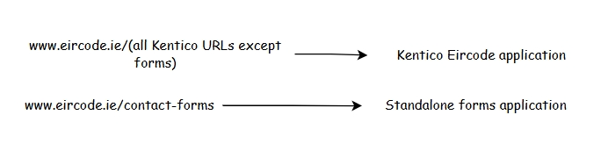
Figure 2 Re-directs between applications

Solution Processing Flow
The following diagram shows a high-level solution of how the solution will be composed. It is followed by a description of the processing sequences.
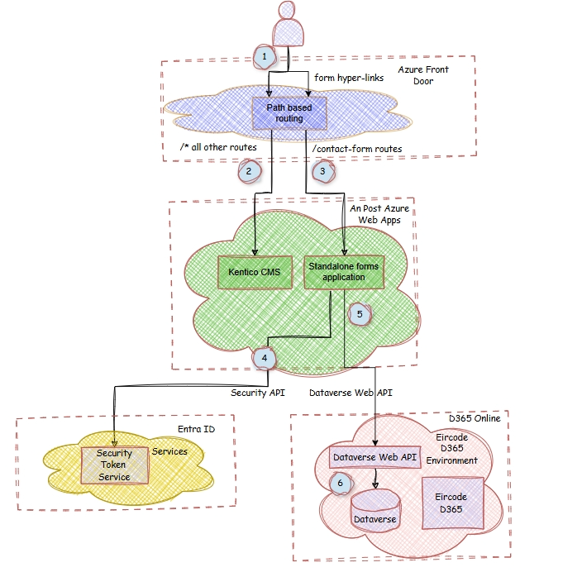
Figure 3 Web forms and D365 integration flow
The processing steps are as follows:
- The user chooses to select form or non-form content.
- When selecting links to non-form content, the user is routed to the Kentico application,
- When selecting links to the forms, the user is routed by Front Door to the custom application.
- The custom web app accepts the form data and then authenticates with Entra ID during the process of requesting an access token.
- Once the token is acquired, the web application attaches it to the API header and makes a Dataverse Web API POST thereby submitting the data for insertion to a nominated Dataverse table.
- Internal processing by the Dynamics 365 solution processes the submitted data.

